**How to Build a Simple Calculator Using HTML, CSS, and JavaScript**

**BY**[**YUVRAJ CHANDRA**](https://www.makeuseof.com/author/yuvraj-chandra/)

UPDATED JUN 17, 2022

Simple, calculated code is the way to go when programming. Check out how to build your own calculator in HTML, CSS, and JS.

The best way to learn JavaScript is to build projects. If you want to become a good web developer, you need to start creating projects as soon as possible. You can start by building beginner-level projects like a simple calculator, digital clock, or stopwatch.

You can make a simple calculator using just core web technologies: HTML, CSS, and JavaScript. This calculator can perform basic mathematical operations like addition, subtraction, multiplication, and division.

**Features of the Calculator**

In this project, you are going to develop a calculator that will have the following features:

1. It will perform basic arithmetic operations like addition, subtraction, division, and multiplication.
2. It will perform decimal operations.
3. The calculator will display **Infinity** if you try to divide any number by zero.
4. It will not display any result in case of invalid expression. For example, 5++9 will not display anything.
5. Clear screen feature to clear the display screen anytime you want.

The code used in this project is available in a [GitHub repository](https://github.com/Yuvrajchandra/Simple-Calculator) and is free for you to use under the MIT license. If you want to have a look at a live version of this project, you can check out [this demo](https://yuvrajchandra.github.io/Simple-Calculator/).

**Components of the Calculator**

The calculator consists of the following components:

**Mathematical Operators**: Addition (+), Subtraction (-), Multiplication (*), and Division (/).

**Digits and Decimal Button**: 0, 1, 2, 3, 4, 5, 6, 7, 8, 9, . .

**Display Screen**: It displays the mathematical expression and the result.

**Clear Screen Button**: It clears all mathematical values.

**Calculate button (=)**: It evaluates the mathematical expression and returns the result.

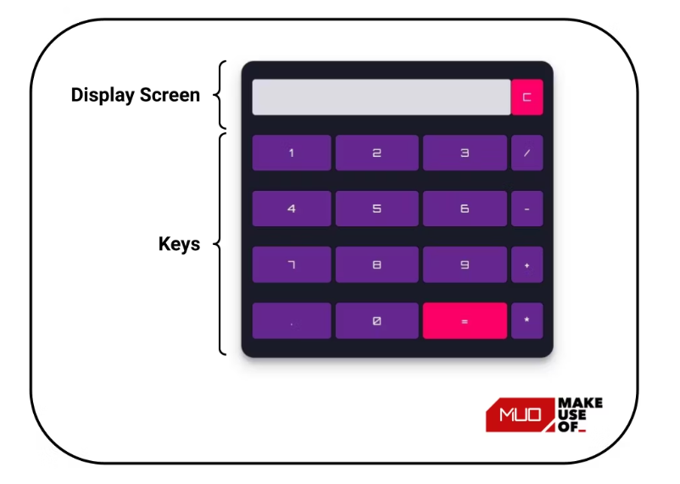

**Folder Structure of the Calculator Project**

Create a root folder that contains the HTML, CSS, and JavaScript files. You can name the files anything you want. Here the root folder is named **Calculator**. According to the standard naming convention, the HTML, CSS, and JavaScript files are named **index.html**, **styles.css**, and **script.js** respectively.

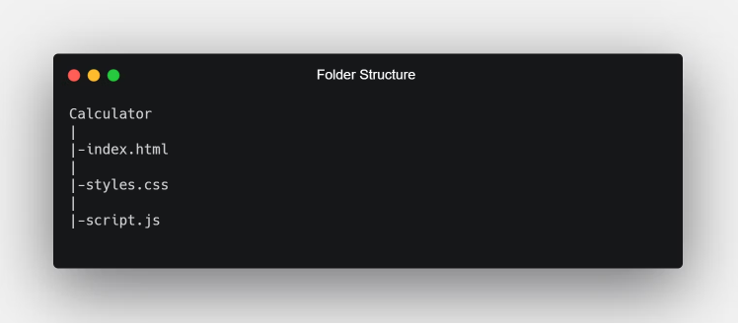

**HTML Code**

Open the **index.html** file and paste the following HTML code for the calculator:

<!DOCTYPE html>  
<html lang="en" dir="ltr">  
   
<head>  
 <meta charset="utf-8">  
 <title>Simple Calculator using HTML, CSS and JavaScript</title>  
 <link rel="stylesheet" href="styles.css">  
</head>  
   
<body>  
   
<table class="calculator" >  
 <tr>  
 <td colspan="3"> <input class="display-box" type="text" id="result" disabled /> </td>  
   
 <!-- clearScreen() function clears all the values -->  
 <td> <input type="button" value="C" onclick="clearScreen()" id="btn" /> </td>  
 </tr>  
 <tr>  
 <!-- display() function displays the value of clicked button -->  
 <td> <input type="button" value="1" onclick="display('1')" /> </td>  
 <td> <input type="button" value="2" onclick="display('2')" /> </td>  
 <td> <input type="button" value="3" onclick="display('3')" /> </td>  
 <td> <input type="button" value="/" onclick="display('/')" /> </td>  
 </tr>  
 <tr>  
 <td> <input type="button" value="4" onclick="display('4')" /> </td>  
 <td> <input type="button" value="5" onclick="display('5')" /> </td>  
 <td> <input type="button" value="6" onclick="display('6')" /> </td>  
 <td> <input type="button" value="-" onclick="display('-')" /> </td>  
 </tr>  
 <tr>  
 <td> <input type="button" value="7" onclick="display('7')" /> </td>  
 <td> <input type="button" value="8" onclick="display('8')" /> </td>  
 <td> <input type="button" value="9" onclick="display('9')" /> </td>  
 <td> <input type="button" value="+" onclick="display('+')" /> </td>  
 </tr>  
 <tr>  
 <td> <input type="button" value="." onclick="display('.')" /> </td>  
 <td> <input type="button" value="0" onclick="display('0')" /> </td>  
   
 <!-- calculate() function evaluates the mathematical expression -->  
 <td> <input type="button" value="=" onclick="calculate()" id="btn" /> </td>  
 <td> <input type="button" value="*" onclick="display('*')" /> </td>  
 </tr>  
</table>  
   
<script type="text/javascript" src="script.js"></script>  
   
</body>  
   
</html>

This project uses a **<table>** tag to create the overall structure of the calculator. The **<table>** tag contains five rows which represent five horizontal sections of the calculator. Each row has a corresponding **<tr>** tag. Each **<tr>** tag contains **<td>** tags which hold the display screen and buttons of the calculator.

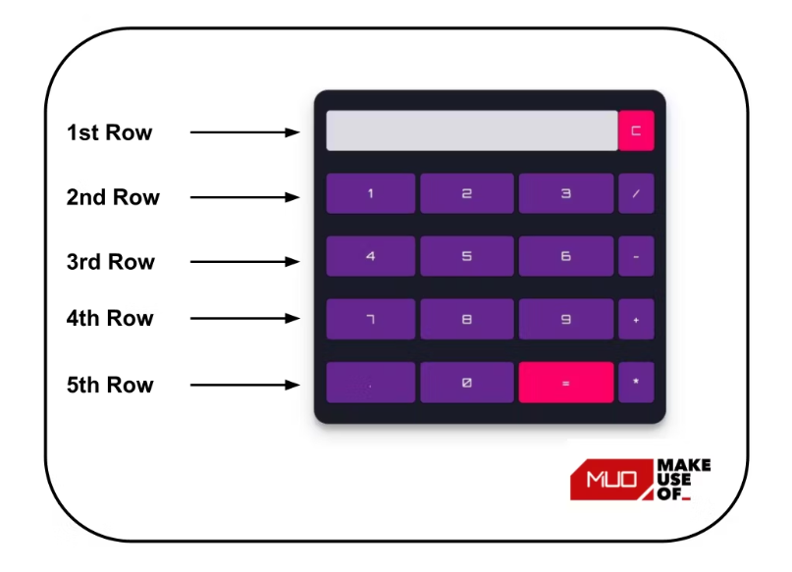

**CSS Code**

Open the **styles.css** file and paste the following CSS code for the calculator:

@import url('<https://fonts.googleapis.com/css2?family=Orbitron>&display=swap');  
.calculator {  
 padding: 10px;  
 border-radius: 1em;  
 height: 380px;  
 width: 400px;  
 margin: auto;  
 background-color: #191b28;  
 box-shadow: rgba(0, 0, 0, 0.19) 0px 10px 20px, rgba(0, 0, 0, 0.23) 0px 6px 6px;  
}  
.display-box {  
 font-family: 'Orbitron', sans-serif;  
 background-color: #dcdbe1;  
 border: solid black 0.5px;  
 color: black;  
 border-radius: 5px;  
 width: 100%;  
 height: 65%;  
}  
#btn {  
 background-color: #fb0066;  
}  
input[type=button] {  
 font-family: 'Orbitron', sans-serif;  
 background-color: #64278f;  
 color: white;  
 border: solid black 0.5px;  
 width: 100%;  
 border-radius: 5px;  
 height: 70%;  
 outline: none;  
}  
input:active[type=button] {  
 background: #e5e5e5;  
 -webkit-box-shadow: inset 0px 0px 5px #c1c1c1;  
 -moz-box-shadow: inset 0px 0px 5px #c1c1c1;  
 box-shadow: inset 0px 0px 5px #c1c1c1;  
}

The above CSS styles the calculator. [**The .class selector in CSS**](https://www.makeuseof.com/how-to-target-part-of-a-web-page-using-css-selectors/) selects elements with a specific class attribute. The **.calculator** and **.display-box** class selectors style the table structure and the display screen of the calculator respectively. **@import** imports the **Orbitron font-family** from Google fonts.

**JavaScript Code**

Open the **script.js** file and add functionality to the simple calculator using the following JavaScript code:

// This function clear all the values  
function clearScreen() {  
 document.getElementById("result").value = "";  
}  
   
// This function display values  
function display(value) {  
 document.getElementById("result").value += value;  
}  
   
// This function evaluates the expression and returns result  
function calculate() {  
 var p = document.getElementById("result").value;  
 var q = eval(p);  
 document.getElementById("result").value = q;  
}

**Understanding the JavaScript Code**

The**clearScreen()**, **display()**, and **calculate()** functions add functionality to the Calculator.

**Clearing Values**

The**clearScreen()** function access the DOM using the **id** of the result and clear its value by assigning it an empty string. You can [**use DOM selectors**](https://www.makeuseof.com/dom-selectors-how-to-use/) to target various components of a page.

function clearScreen() {  
 document.getElementById("result").value = "";  
}

**Displaying Values**

The **display()** function accesses the DOM using the **id** of the result and appends the value of the clicked button to the result.

function display(value) {  
 document.getElementById("result").value += value;  
}

**Evaluating Expression**

The**calculate()** function accesses the DOM using the **id** of the result and evaluates the expression using the **eval()** function. The evaluated value of the expression is again assigned to the result.

The JavaScript **eval()** function evaluates an expression that you pass to it. It returns the result of that expression.

function calculate() {  
 var p = document.getElementById("result").value;  
 var q = eval(p);  
 document.getElementById("result").value = q;  
}